IBM Rational Quality Manager Integration with

IBM Rational Functional Tester

By

V.Niranjan

[vniranjan72@outlook.com](mailto:vniranjan72@outlook.com)

Table of Contents

Introduction 3

Installing Rational Functional Tester v8.6 3

Configure the IBM Rational Quality Manager adapter 4

Sample Script recorded using IBM Rational Functional Tester 5

Creating Test Case in IBM Rational Quality Manager 6

Import the IBM Rational Functional Tester script in to IBM Rational Quality Manager 7

Link the automated test script to the test case 11

Summary 14

# Introduction

In this article we will look at IBM Rational Quality Manager (RQM) integration with IBM Rational Functional Tester (RFT).

**IBM Rational Quality Manager** is the Test Management solution as a part of the IBM Rational CLM. It offers capability to create Test Plans, Test Cases, and Test Scripts. It offers manual execution of the test cases by default out of the box with defect tracking well integrated as a part of IBM Rational Collaborative Life Cycle Management platform (CLM). It also enables you to integrate and run automated tests created with other testing tools like IBM Rational Functional Tester, Selenium, HP QTP etc.

**IBM Rational Functional Tester** is the automated functional and regression testing tool which provides automated and data driven testing capabilities for GUI and Web based applications. It supports applications based on Java, .NET, SAP and Siebel. On the windows platform IBM RATIONAL FUNCTIONAL TESTER provides complete recording, playback and execution capabilities. The resulting script is generated in JAVA language if the testers are using Java OR Visual Basic .Net if the testers use Visual Studio.NET.

IBM RATIONAL FUNCTIONAL TESTER comes built in with Eclipse wherein the testers can do complete recording, playback and execution of the scripts generated in JAVA language.

This article will focus on using IBM Rational Quality Manager and integration with IBM RATIONAL FUNCTIONAL TESTER for Java based applications.

# Installing Rational Functional Tester v8.6

Please refer to the following URL for complete instructions on installing IBM RATIONAL FUNCTIONAL TESTER v8.6

<http://www.ibm.com/support/knowledgecenter/SSJMXE_8.6.0/com.ibm.rational.test.ft.install.doc/topics/t_installing_offering.html>

Once IBM RATIONAL FUNCTIONAL TESTER is installed you will get to see the IBM RATIONAL QUALITY MANAGER Integration Adapter installed by default along with it as shown below.

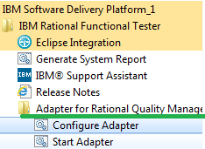

# Configure the IBM Rational Quality Manager adapter

The IBM RATIONAL QUALITY MANAGER adapter needs to be configured in order to use with IBM RATIONAL FUNCTIONAL TESTER. To start the configuration click on **Configure Adapter** and enter the information based on your IBM RATIONAL QUALITY MANAGER installation like the JAZZ server URL, User ID, Password and select the IBM RATIONAL QUALITY MANAGER Project area to be integrated with IBM Rational Functional Tester.

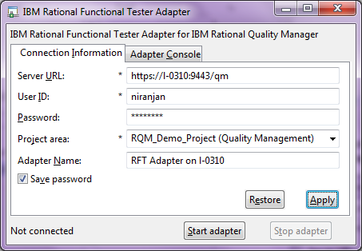

Click on **Start Adapter** and you should see the message in the **Adapter Console TAB as Connected**.

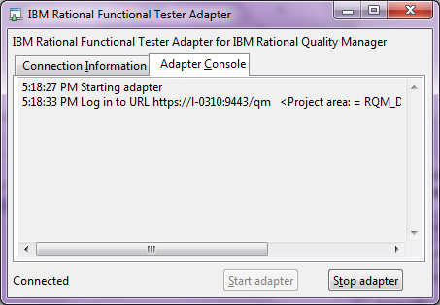

**Please minimize the screen and do not close it during the entire course of integration.**

# Sample Script recorded using IBM Rational Functional Tester

The screen below shows a sample IBM RATIONAL FUNCTIONAL TESTER script created using the recording feature. More on usage of IBM Rational Functional Tester can be found @ the URL

<http://www.ibm.com/support/knowledgecenter/SSJMXE_8.6.0>

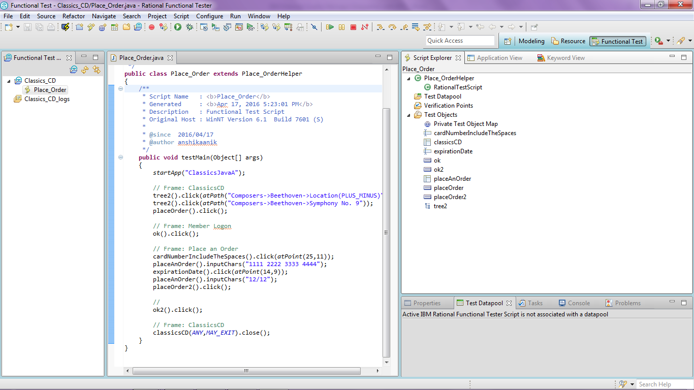

The above script will be linked to a test case created in IBM RATIONAL QUALITY MANAGER using the integration.

# Creating Test Case in IBM Rational Quality Manager

Create a test case in RQM called **Place Order** and click OK. The above script recorded in IBM Rational Functional Tester will be linked to the test case.

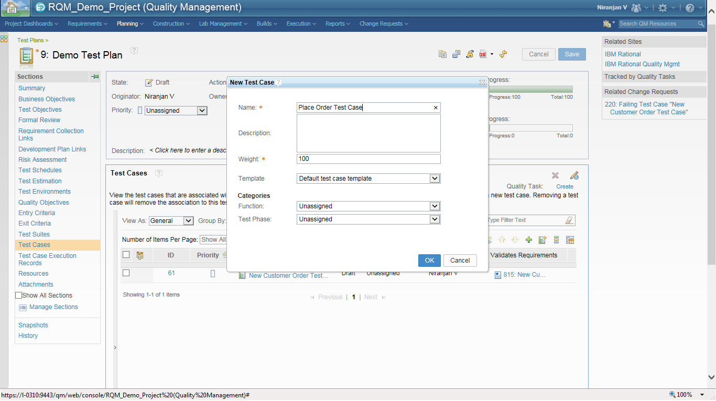

Remember to Save the changes after creating the Test Case.

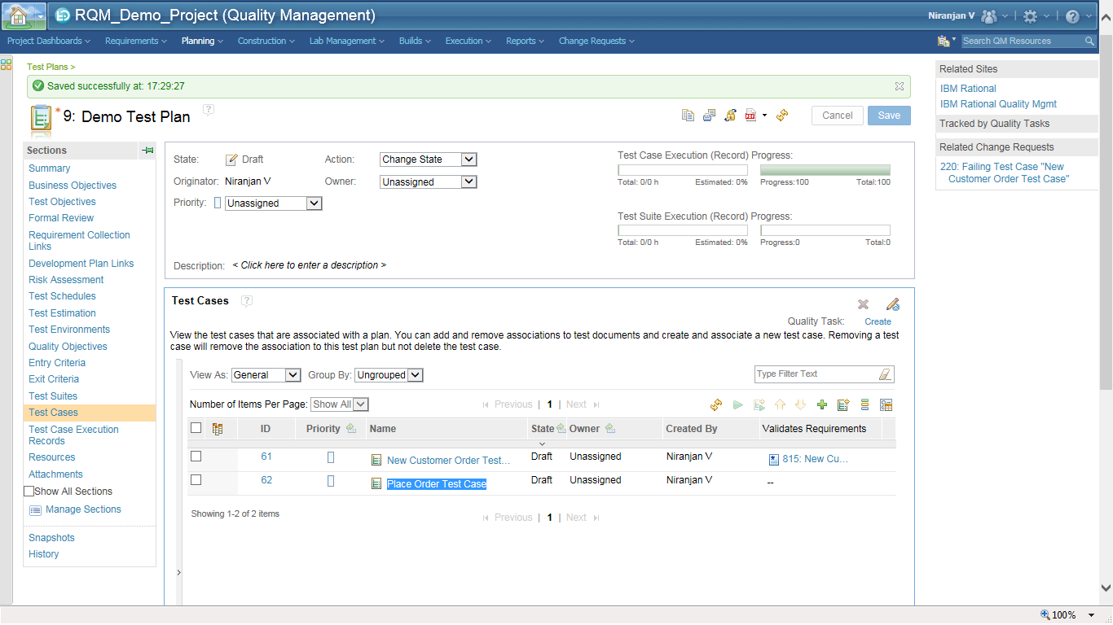

# Import the IBM Rational Functional Tester script in to IBM Rational Quality Manager

By default Manual Test Scripts can be linked directly by default to the Test Cases created in IBM Rational Quality Manager. To link the IBM Rational Functional Tester script to the Test Case created above you will need to import the script created by recording in IBM Rational Functional Tester in to IBM Rational Quality Manager.

In IBM Rational Quality Manager to import the IBM Rational Functional Tester script click on **Construction🡪 Import - Test Scripts**

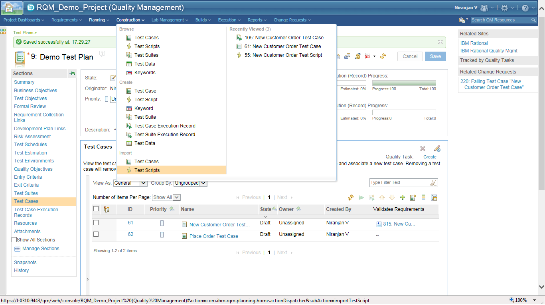

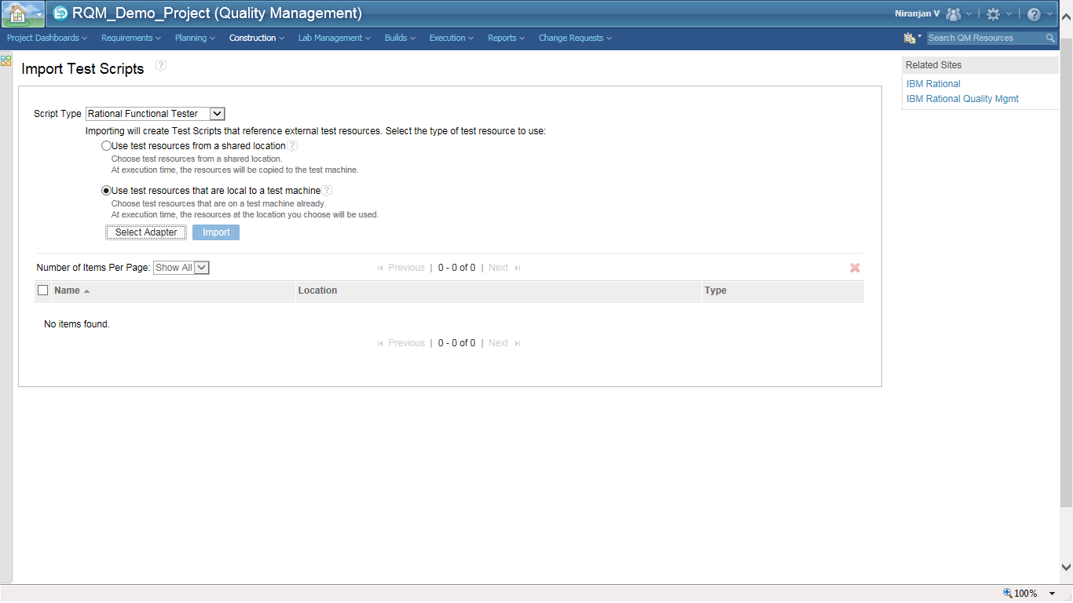

Click on **Select Adapter** and select the adapter that was configured initially**.**

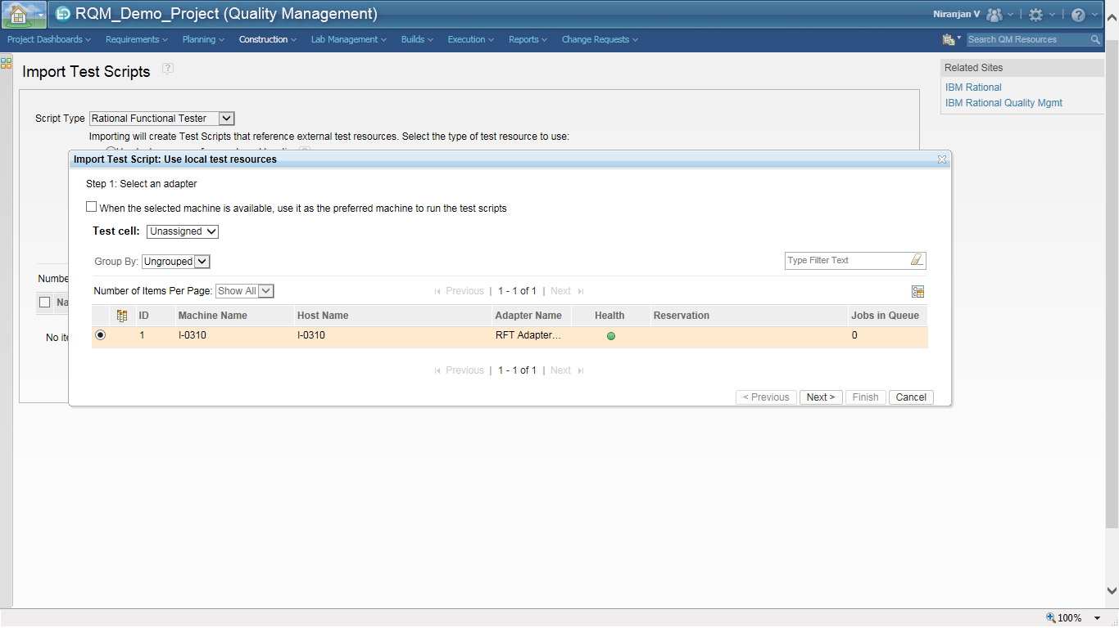

Since the IBM RATIONAL QUALITY MANAGER adapter was started it is displayed.

Click on **Next** and select the workspace path which contains the IBM Rational Functional Tester script.

In Step 2 which comes up enter the IBM Rational Functional Tester Eclipse Workspace path followed by the IBM RATIONAL FUNCTIONAL TESTER project. This is usually the path which is entered while launching IBM RATIONAL FUNCTIONAL TESTER for recording any scripts.

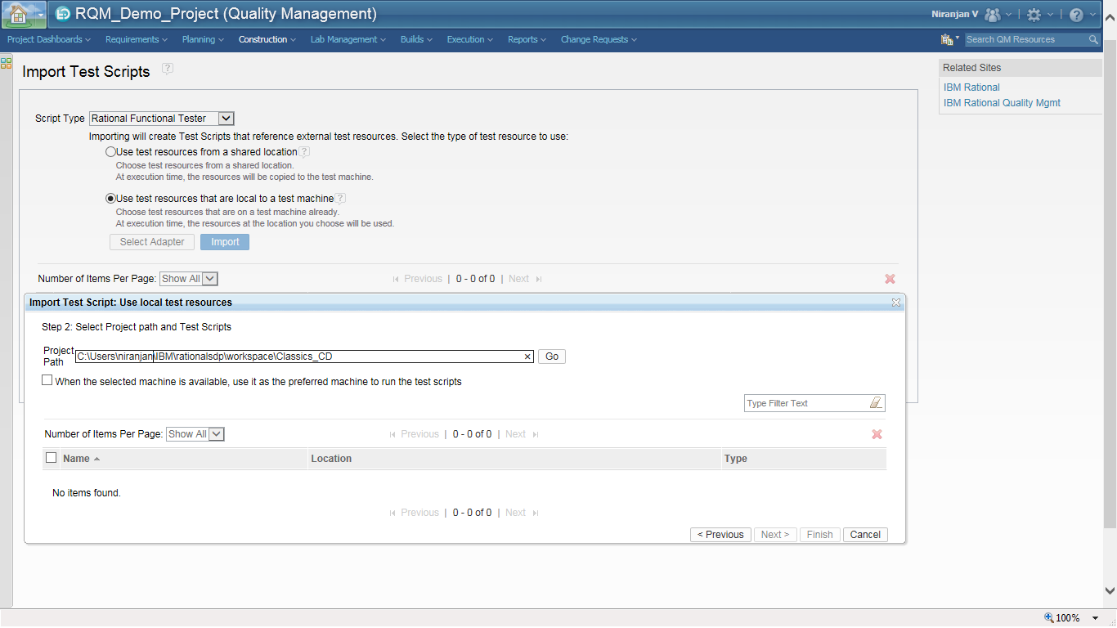

Click on **Go** button. You will now be able to select the automated script which was created by recording capability of IBM RATIONAL FUNCTIONAL TESTER.

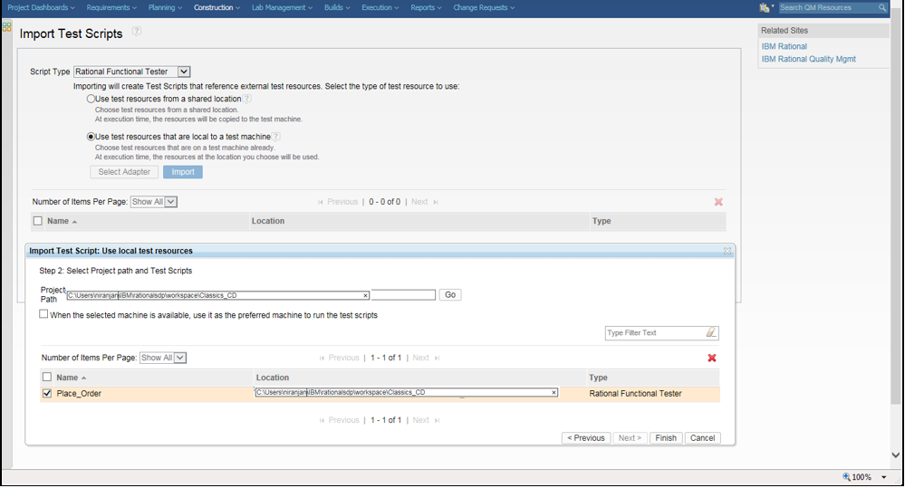

Click on **Finish.**

Select the script and click on the **Import** button to complete the importing of the script in to IBM RATIONAL QUALITY MANAGER.

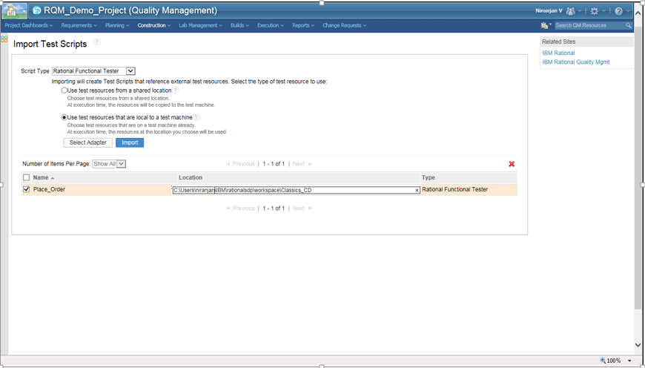

After the import is completed the script type is shown as Rational Functional Tester

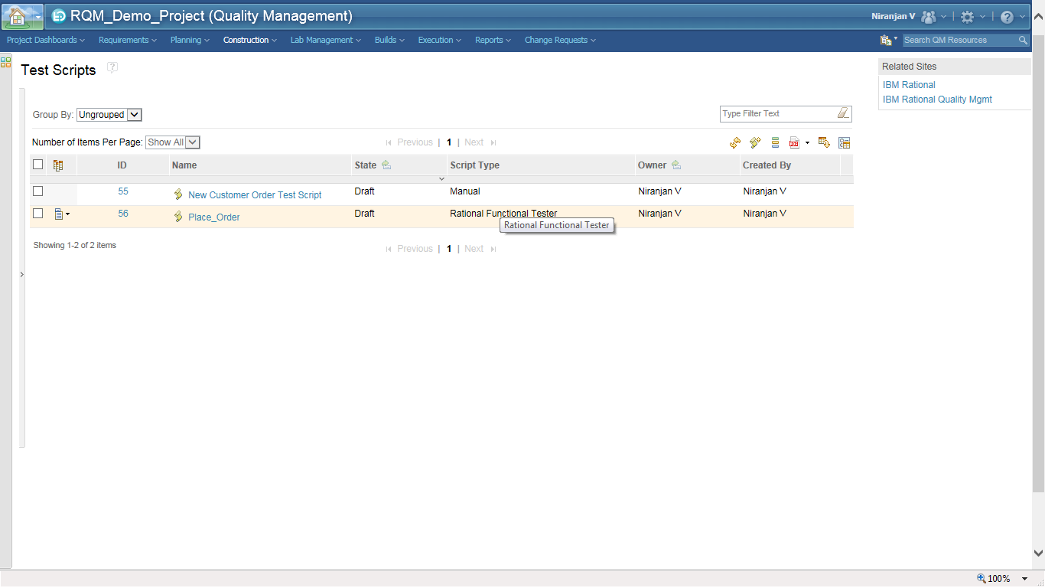

# Link the automated test script to the test case

Browse to open the Test Case created previously. In IBM RATIONAL QUALITY MANAGER select **Construction🡪 Browse Test Case.** Click on the Place Order test case and go to the Test Scripts section.

Select **Add Test Script**

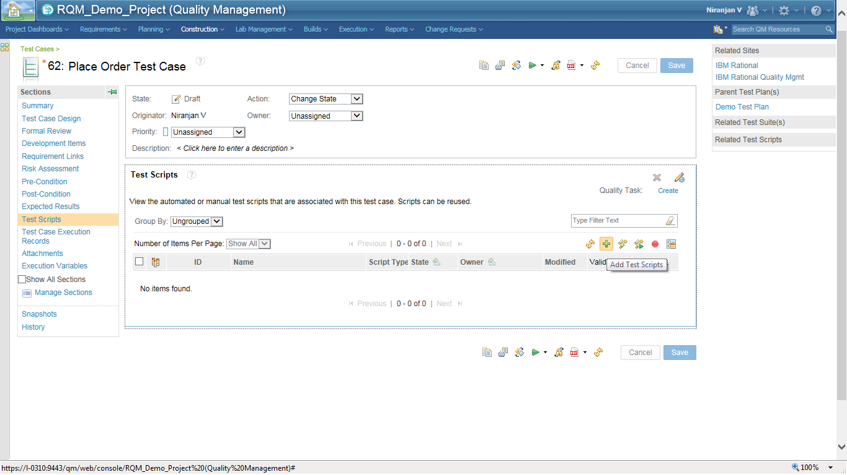

Select the check box next to the script created by IBM Rational Functional Tester and click on **Add and Close.** Remember to **Save.**

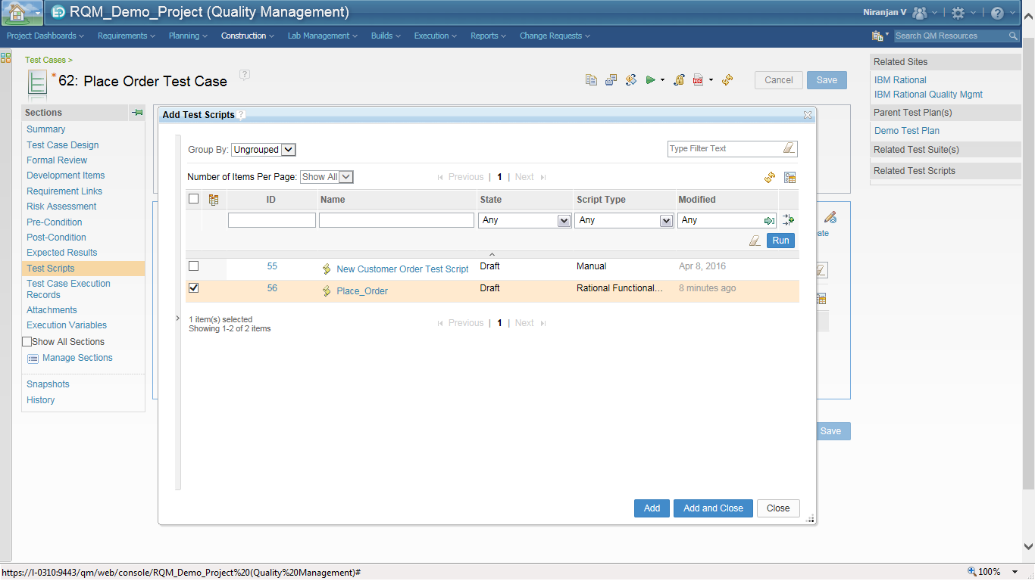

Select the Test Script just imported and click on **Run.** The test script will run as playback and the test result will be imported in to IBM RATIONAL QUALITY MANAGER.



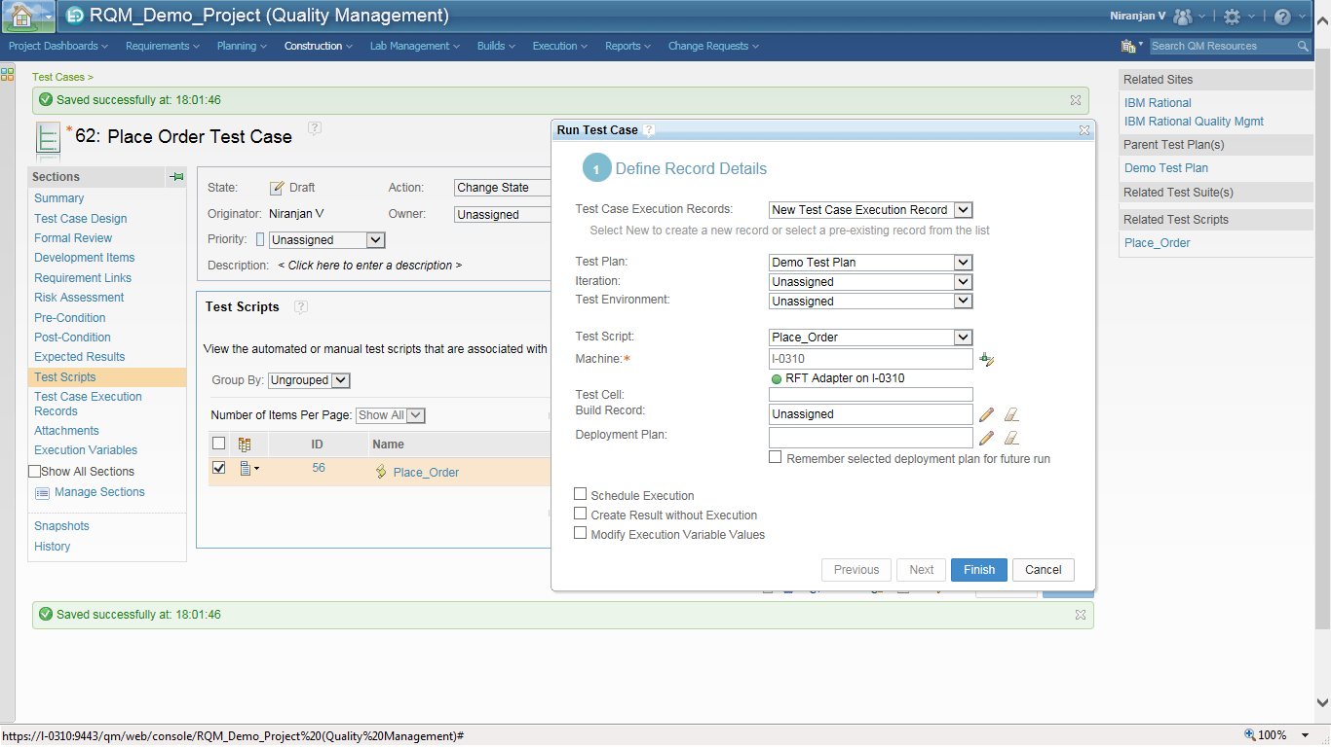

The result is now displayed. Click on **Show result** to look at the log files generated out of the execution.

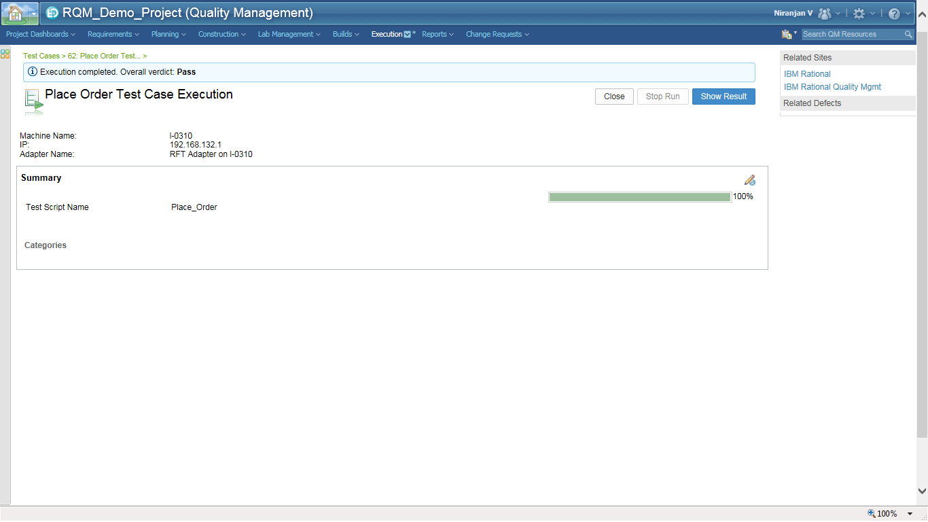

The resulting log file are also imported in to IBM RATIONAL QUALITY MANAGER as shown in the below figure.

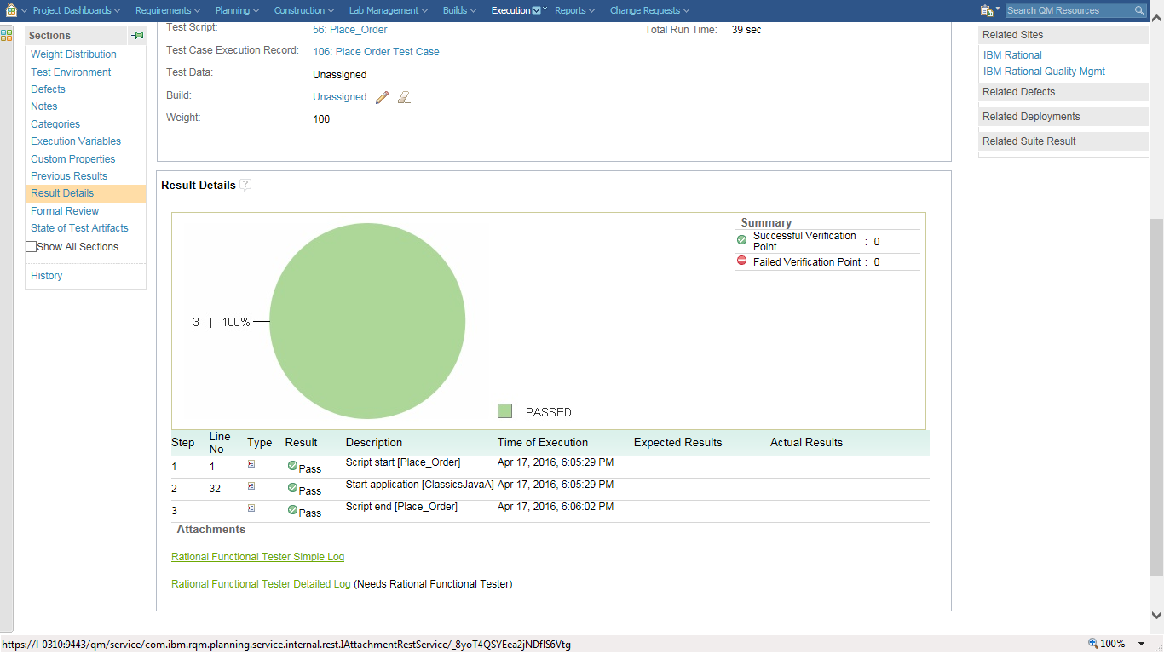

# Summary

In this article we have seen

* Installing IBM Rational Functional Tester
* How to configure IBM Rational Quality Manager adapter for IBM Rational Functional Tester integration
* Import IBM Rational Functional Tester scripts in to IBM Rational Quality Manager
* Execute the IBM Rational Functional Tester scripts from Rational Quality Manager Test Case

In my next article I will show how IBM Rational Quality Manager is integrated with another popular automated testing tool called Selenium.